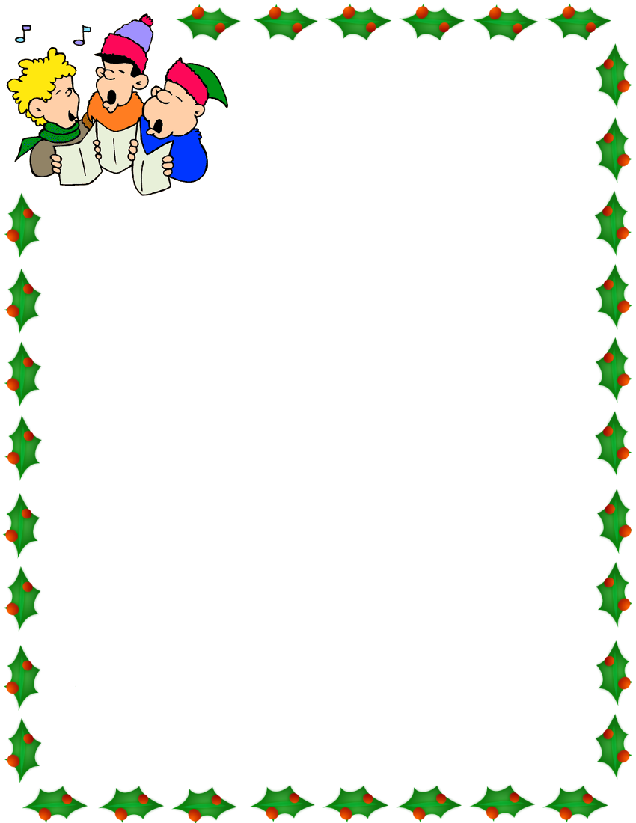
Title: Under Construction
En Construction

Handbells:
Joy to the World
Frosty the Snowman

Grade Three:
I Saw Three Ships
Sleigh Ride

Grade Four:
Light the Candles All Around the World

Grade Five:
Deck the Halls

Grade Six:
Chocolat Chaud
Wizards in Winter

Finale :
Le temps des fêtes
(Holiday, Holiday)

G.F. Handel Arr. Kirtsy Mitchell
Jack Rollins and Steve Nelson
Arr. By Tammy Waldrop

Traditional English arr. John Riggio
Leroy Anderson

Teresa Jennings

Teresa Jennings

Glen Ballard and Alan Silverstri
Arr. By Roger Emerson
Trans-Siberian Orchestra

Teresa Jennings

Written and Directed By:
Glenda Pickering

Translations:
May Viney

Hosts:
Ava Rogers
Kenan Sylvester

Actors:
Construction worker 1 (Forman): Avery Nault
Construction worker 2: Lauren Bayne
Construction worker 3: Alexander Sudyk
Construction worker 4: Gian-Marco Aguilar-Kamunga
Construction worker 5: Rowan Mills
Construction worker 6: Ashley Tennant

Powerpoint:
Honya Bianchini

Technical help:
Evan Jones
Mme Garneau

Art Presentation:
Teachers in charge: Mme Fortin and Mme Devinge
Art Club

Special Thanks: I would like to thank all the staff for their hard work and support during this busy time. Mme Aasen and Mme Bourgoin for help practicing with the actors and actresses, parent council for their continuing support of the music program, parent volunteers who helped with the concert, my family for their patience and understanding, and last but not least the students. Thank you for all your hard work!

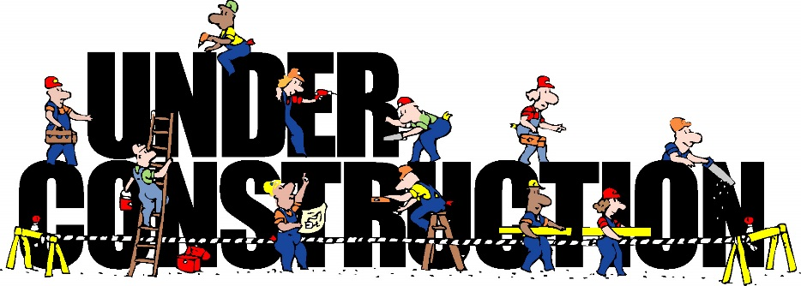

Under Construction
En Construction
Concert Two
Grade 3-6
Friday, December 16, 2016
7:20-8:00 PM

